How A Quick Release Works: The quick-release device uses tension to secure the wheel of your bicycle to the frame. Tension is controlled by the tension nut, so it is important to make sure that the tension nut is adjusted correctly. If there is too much tension, the quick-release lever will not close. If there is too little tension, the wheel will not be held in place. The following instructions explain how to install your new quick-release device.
A. Removing the Old Device
1. With the bicycle wheels on a level surface and the bicycle supported in an upright position, turn the wheel quick release lever to the open position.
2. Hold the quick release lever so that it cannot rotate, and unscrew the tension adjusting nut counter clockwise until it comes off the skewer shaft.
3. Remove the tension adjusting nut cone spring and pull the skewer out of the hub.
4. Put the tension adjusting nut cone spring back on the skewer, thread the tension adjusting nut back on to the skewer shaft and put the old quick release mechanism aside.
B. Attaching the Wheel Using the New Device
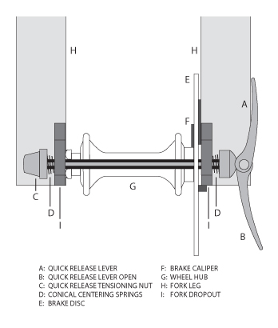
1. Remove the tension adjusting nut and its cone spring from the replacement quick-release mechanism.
2. Lightly oil the skewer threads, the skewer shaft and the quick release lever pivot, and insert the skewer into the hollow axle of the wheel hub, with the lever on the left side of the bike. The left side of the bike is your left side when riding the bike.
3. Replace the tension adjusting nut’s cone spring, small end first, on to the end of the skewer, and thread on the tension adjusting nut until the clamping face of the quick release lever in its fully open position and the face of the adjusting nut just touch the faces of the frame dropouts.
4. While pushing the wheel firmly to the top of the slots in the fork dropouts, and at the same time centering the wheel rim in the fork, move the cam lever upwards and swing it into the CLOSED position. The lever should now be parallel to the fork blade and curved toward the wheel. To apply enough clamping force, you should have to wrap your fingers around the fork blade for leverage, and the lever should leave a clear imprint in the palm of your hand.
NOTE: If the lever cannot be pushed all the way to a position parallel to the fork blade, return the lever to the OPEN position. Then turn the tension adjusting nut counterclockwise one-quarter turn and try tightening the lever again.
WARNING: Securely clamping the wheel with a cam action retention device takes considerable force. If you can fully close the cam lever without wrapping your fingers around the fork blade for leverage, the lever does not leave a clear imprint in the palm of your hand, and the serrations on the wheel fastener do not emboss the surfaces of the dropouts, the tension is insufficient. Open the lever; turn the tension adjusting nut clockwise a quarter turn; then try again.

